**Assignment –6**

**Using Special Operators in Conditions**.

1. **Write two different queries that would produce all orders taken on October 3rd or 4th, 1990**.

mysql> select* from orders

-> where odate IN('1990-10-03' , '1990-10-04');

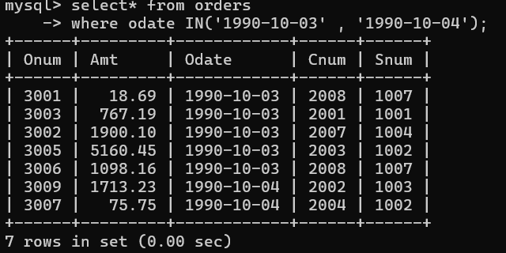

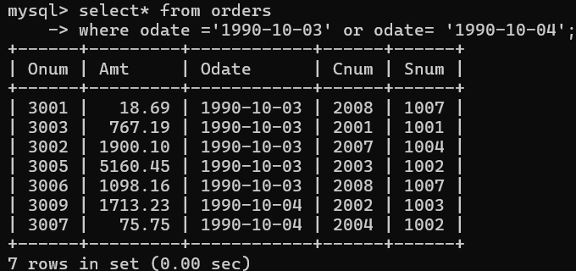

1. **Write a query that selects all of the customers serviced by Peel or Motika. (Hint: the snum field relates the two tables to one another).**

mysql> select * from customers

-> where snum IN

-> (select snum from salespeople where sname= 'peel' or sname = 'motika');

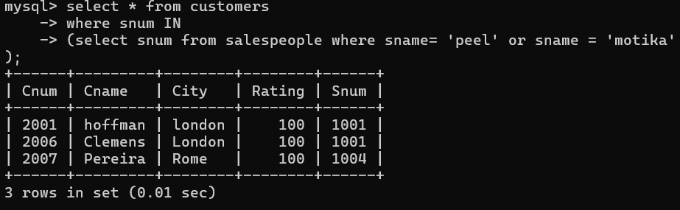

1. **Write a query that will produce all the customers whose names begin with a letter from ‘A’ to ‘G’.**

mysql> select cname, city, rating ,snum

-> from customers

-> where cname >= 'A' and cname <'H';

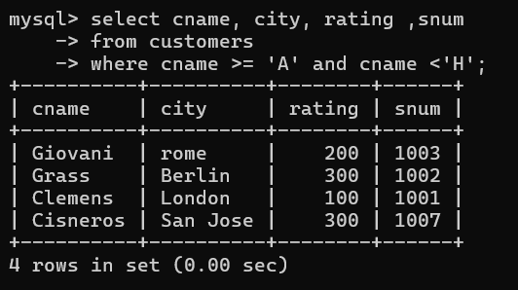

1. **Write a query that selects all customers whose names begin with the letter ‘C’.**

mysql> select *

-> from customers

-> where cname LIKE 'C%';

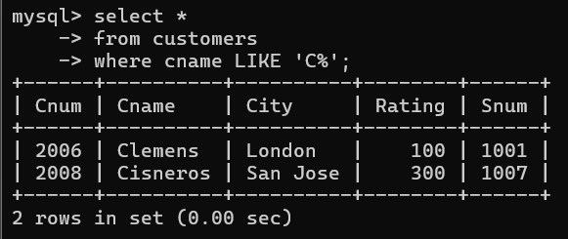

1. **Write a query that selects all orders except those with zeroes or NULLs in the amt field.**

mysql> select *from orders

-> where amt is not null;

